E-Verify Reporting- {PeopleSoft instructions}

For Service Orders greater than $2,499.99, an E-Verify form is required {otherwise known as Contractor Affidavit form}. Vendor must complete form including notarizing. EVerify # {Federal Work Authorization User ID #} is typcially 4 to 7 numbers long, has no letters and is NOT their FEI/W9 number. See last page for an example of a Vendor’s Company Information page from E-Verify system, which highlights required EV#.
Note: There are also forms for Sub-Contractors and Sub Sub Contractors if needed. See DNR Intranet/Administrative Services/Purchasing.

Vendor is Exempt only if: a) The company has only 1 employee {need copy of their Driver’s License} , b) the vendor is a GEORGIA governmental entity and c) Canadian Company.
The State Accounting Office has worked to make the report due to the Department of Audits easier for Agencies. They have modified the main page of the Purchase Order to include E-Verify. Please follow these instructions:
On the Maintain Purchase Order page, see Services PO box – It defaults to ‘No’ and should stay no for “goods only” POs and for POs where services are less than $2,500……
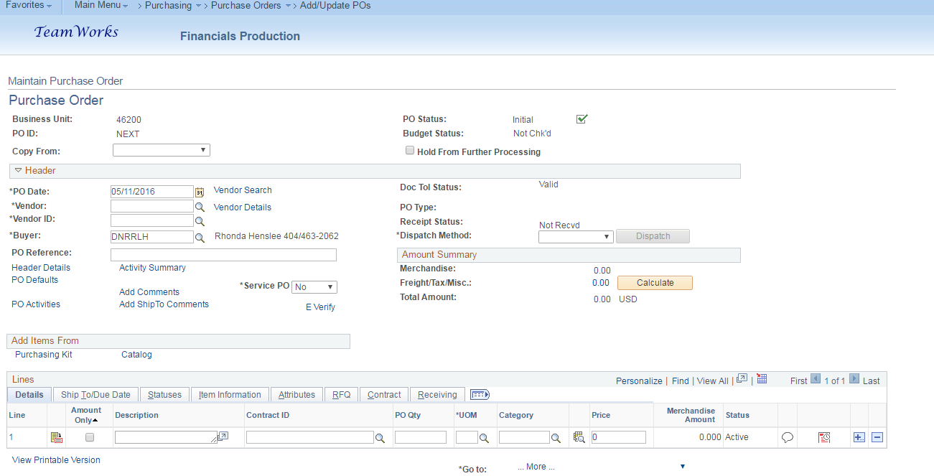
However, if the PO is for a service greater than $2,499.99, click on the down arrow and click ‘Yes’…..

NEW 12/30/2019: Lisa Gunthorp email: Services > $2,500 vs. Entire PO
- When filling out Service PO “YES” please be sure JUST the service portion is over $2500 to qualify, if the entire PO is over $2,500 inclusive of non-service NIGP codes but the service portion is less than $2,500 a everify is not required and you should answer “NO” to service po, accordingly DO NOT populate drop down.

Then click on the E-Verify link…..

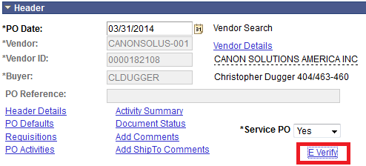

This box pops up…..
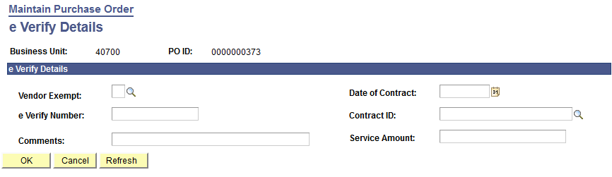
Vendor Exempt: Yes or No???
Yes to Vendor Exempt only if:
- The company has only 1 employee
- The vendor is a GEORGIA governmental entity
- Canadian Company
You MUST still enter Contract ID, Date of Contract, and Service Amount

Otherwise No to Vendor Exempt and fill in the following:
Date of Contract is the Date of the PO
e-Verify Numbers are 4 to 7 digits….NO letters
Contract ID is the PO # {last 6 numbers} or Contract # {statewide or agency contract}
Service Amount is the Amount of the PO
Click OK when done to go back to the main page.
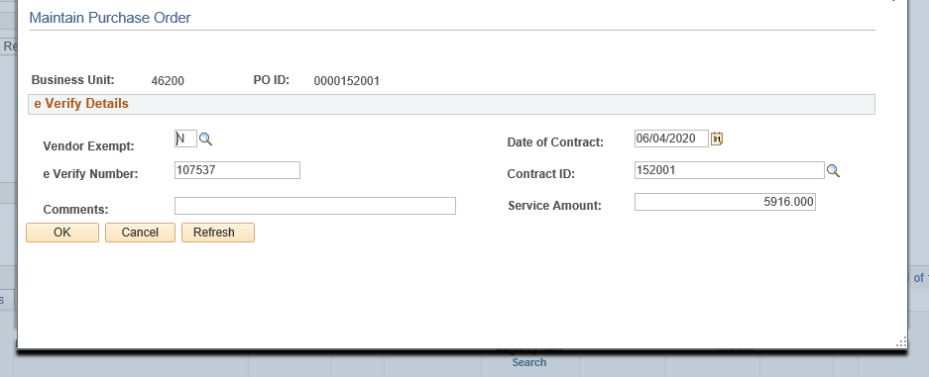
Now you need to attach the E-verify affidavit….click on Add Comments link
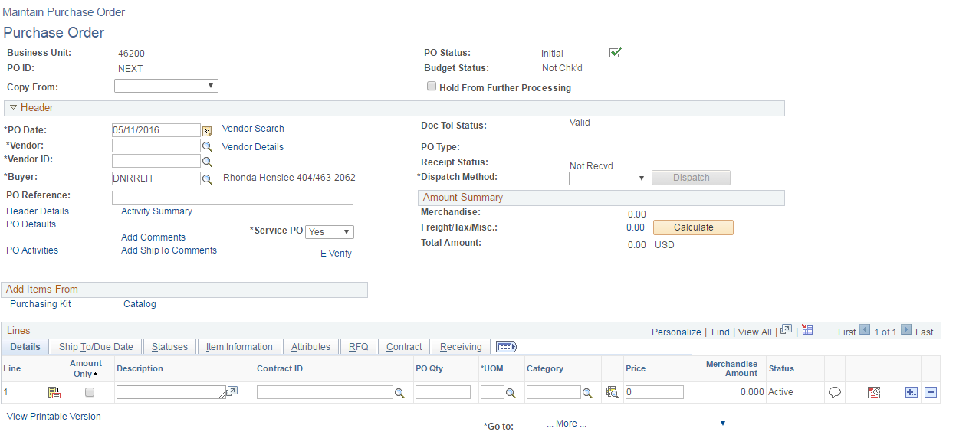

Click on Use Standard Comments link…..
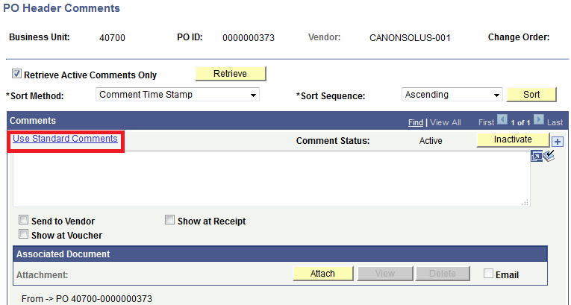

This box comes up….
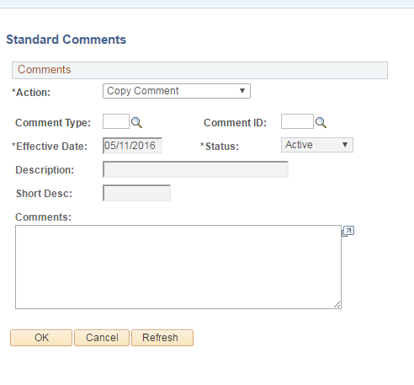

In the Comment Type box choose PO….
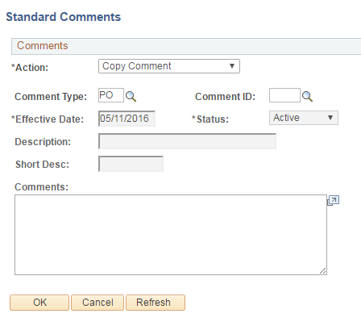
Then in the Comment ID box choose EVFY….
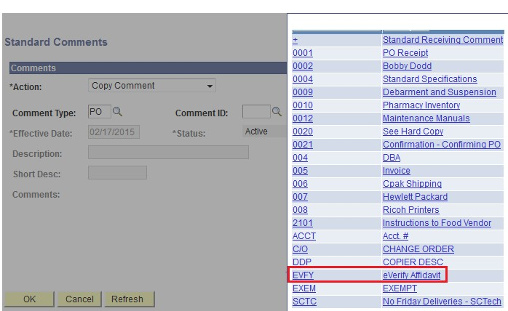

The following verbiage will populate….
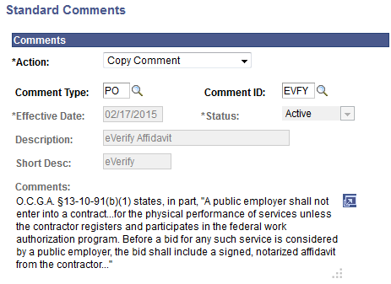
Note: For single owner company, select Comment ID: EX {comment is: Vendor does not have any employees so they are exempt from everify }

Click OK to return to PO Header Comments….then click on the Attach button
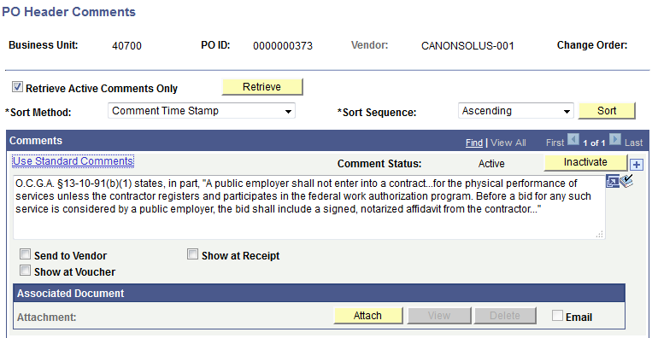
Note: For Single owner company, you will upload PDF image of their driver’s license.

Browse for your completed E-Verify Affidavit and then upload….
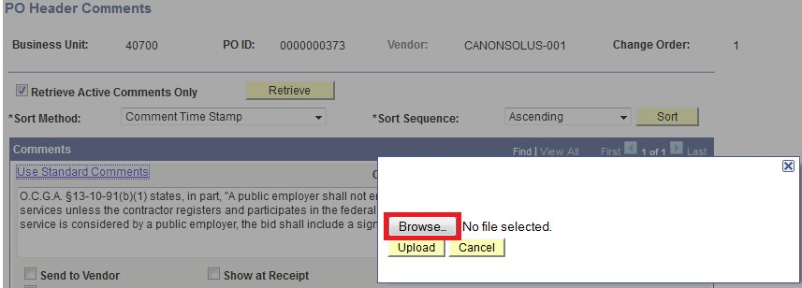

Once uploaded, click on Send to Vendor so the O.C.G.A codes Comments prints on the purchase order.

Mockup of a Vendor’s E-Verify Company Information Page
Many times vendors will complete the affidavit listing an ID number with letters, which most likely is their User ID number {shown in upper right corner} and not their true E-Verify ID number, which is circled in red below.

